Bug 3: Odds in the game do not appear to be correct.
Crown and Anchor games have an approximate 8% bias to the house. So the win : (win+lose) ratio should approximately equal 0.42. This does not appear to be the case.

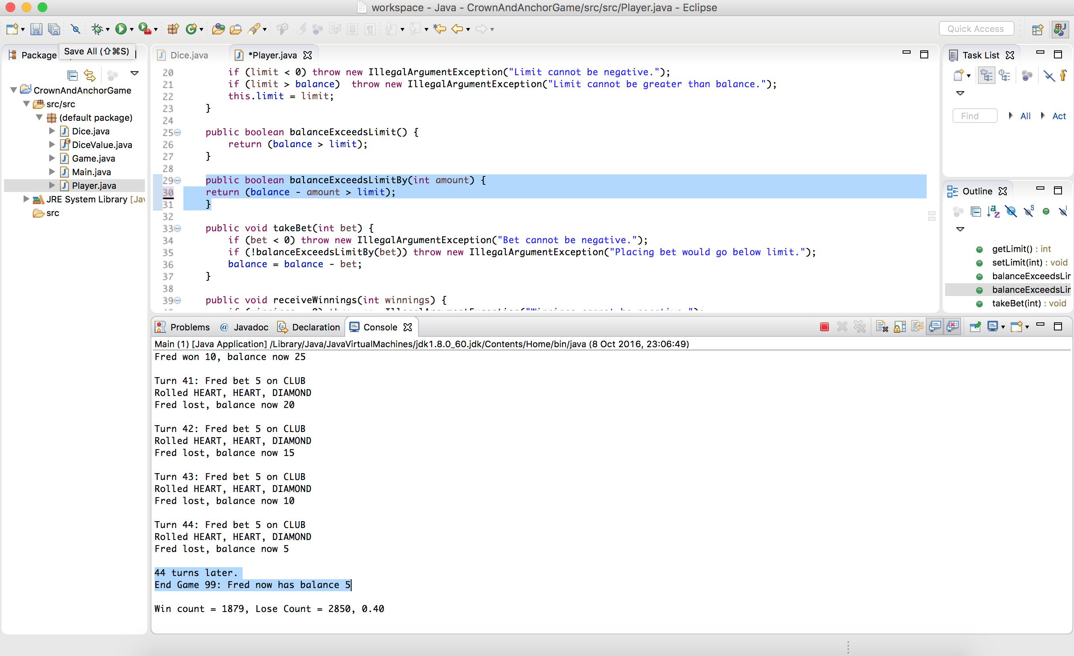
Original code

public boolean balanceExceedsLimitBy(int amount) {
return (balance - amount > limit);
}

fixed code
public boolean balanceExceedsLimitBy(int amount) {
//changed here > to >=
return (balance - amount >= limit);
}
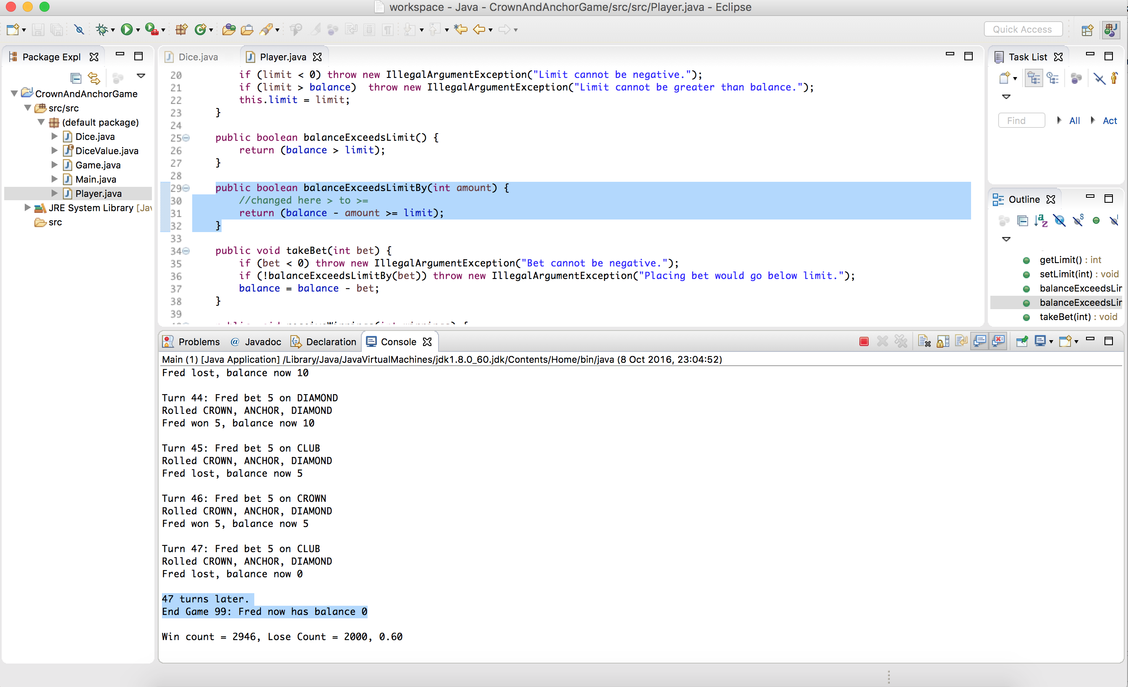

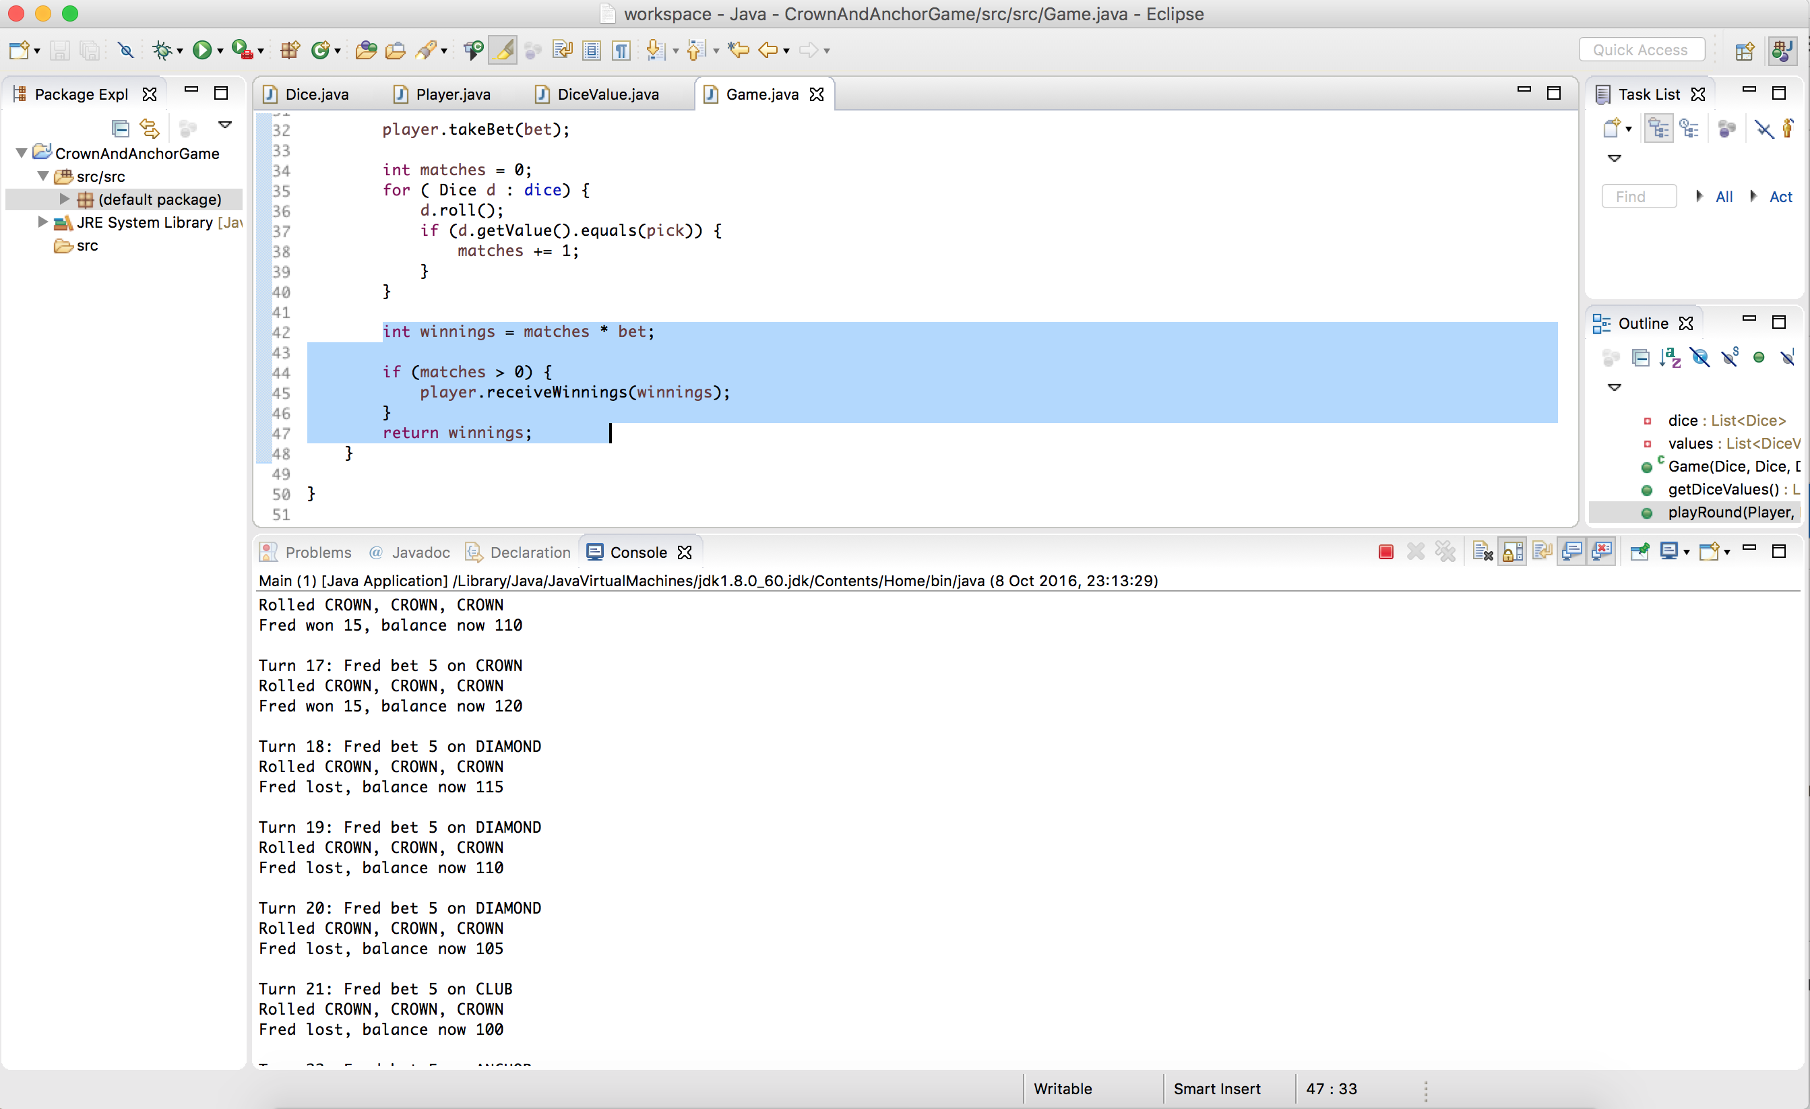

Original Code

int winnings = matches * bet;

if (matches > 0) {

player.receiveWinnings(winnings);

}

return winnings;

Fixed code
int winnings = matches * bet;
if (matches > 0) {
//changed here - added following line
winnings += bet;
player.receiveWinnings(winnings);
}
return winnings;
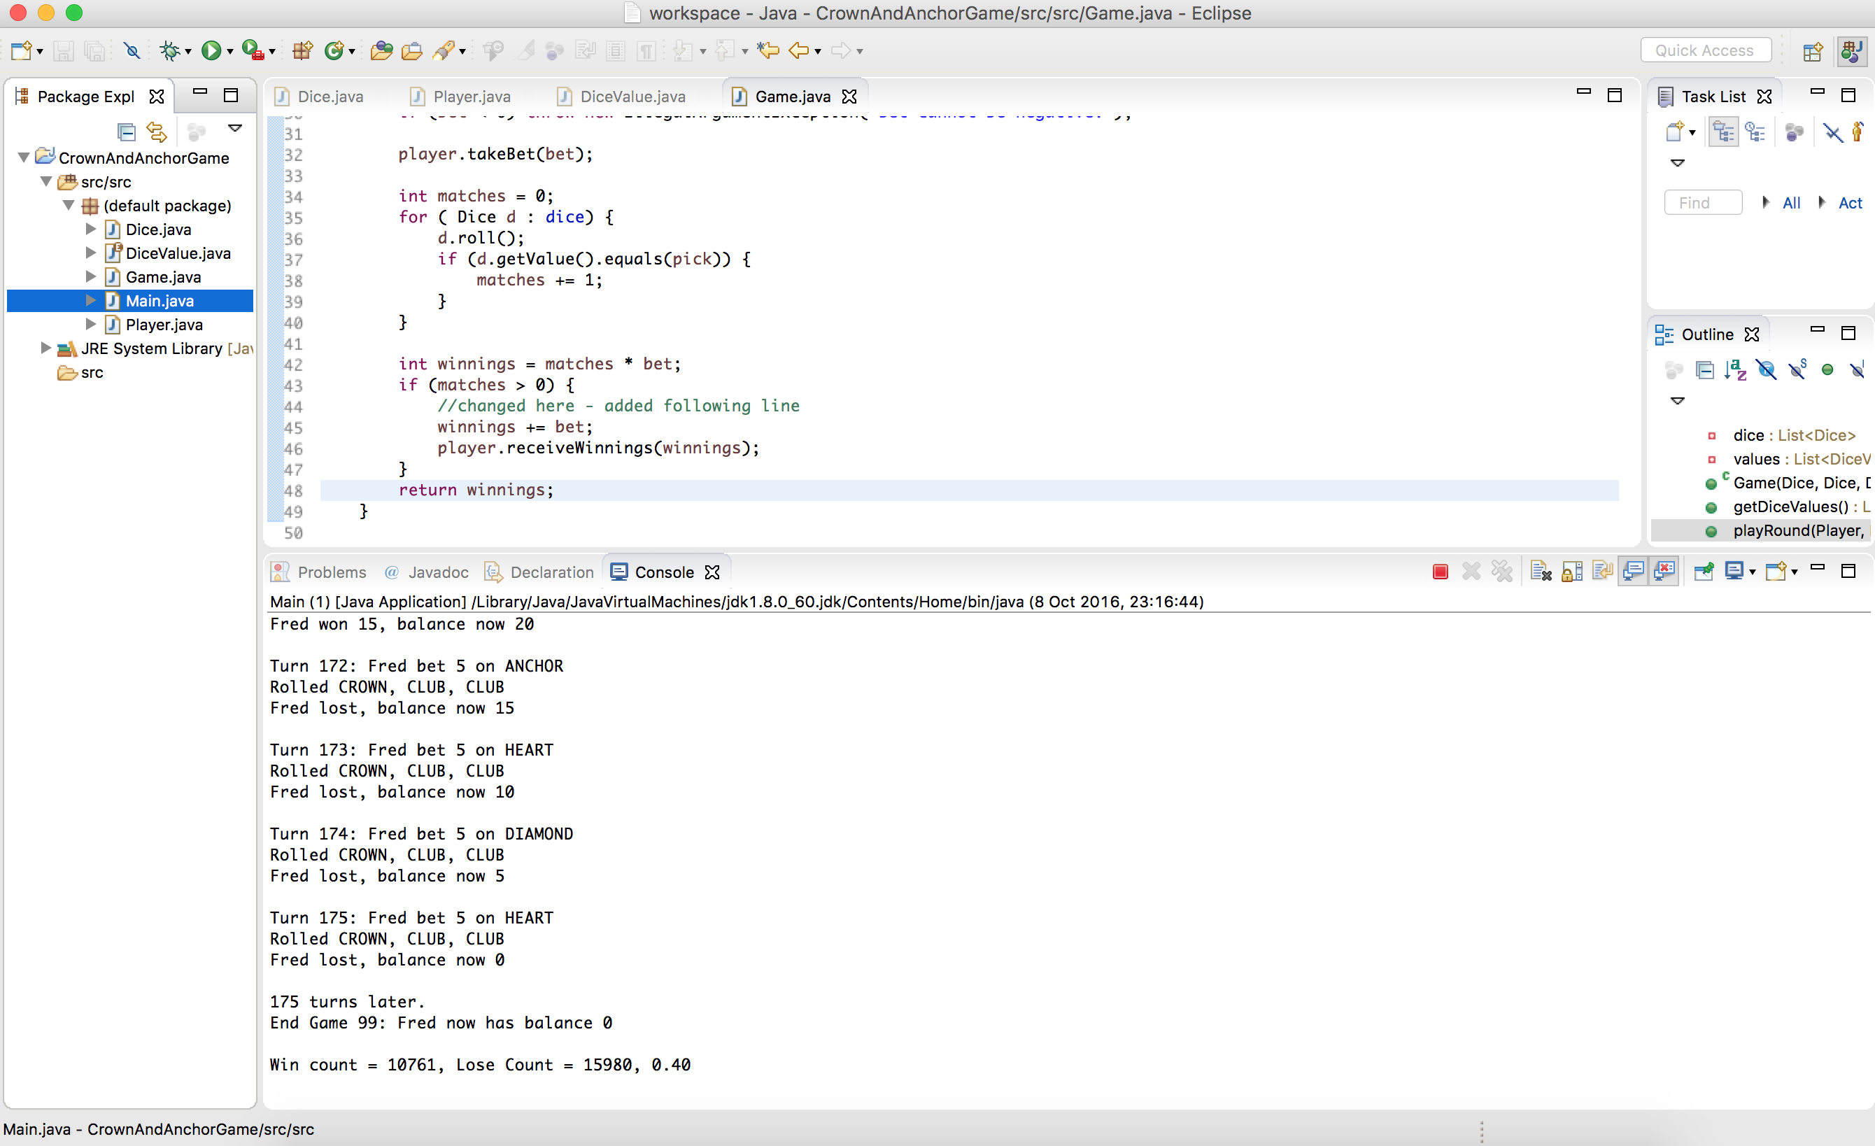

when you fix these 2 codings then winning odds will be fixed automatically

